**Create a Spring Web Project using Maven**

**SpringLearnApplication.java**

package com.cognizant.springlearn;

import org.springframework.boot.SpringApplication;

import org.springframework.boot.autoconfigure.SpringBootApplication;

import org.slf4j.Logger;

import org.slf4j.LoggerFactory;

@SpringBootApplication

public class SpringLearnApplication {

    private static final Logger LOGGER = LoggerFactory.getLogger(SpringLearnApplication.class);

    public static void main(String[] args) {

        SpringApplication.run(SpringLearnApplication.class, args);

        LOGGER.info("STARTED SpringLearnApplication main()");

    }

}

**SpringLearnApplication.class**

package com.cognizant.springlearn;

import org.slf4j.Logger;

import org.slf4j.LoggerFactory;

import org.springframework.boot.SpringApplication;

import org.springframework.boot.autoconfigure.SpringBootApplication;

@SpringBootApplication

public class SpringLearnApplication {

   private static final Logger LOGGER = LoggerFactory.getLogger(SpringLearnApplication.class);

   public SpringLearnApplication() {

   }

   public static void main(String[] args) {

      SpringApplication.run(SpringLearnApplication.class, args);

      LOGGER.info("STARTED SpringLearnApplication main()");

   }

}

**Pom.xml**

<project xmlns="http://maven.apache.org/POM/4.0.0"

         xmlns:xsi="http://www.w3.org/2001/XMLSchema-instance"

         xsi:schemaLocation="http://maven.apache.org/POM/4.0.0

         http://maven.apache.org/xsd/maven-4.0.0.xsd">

    <modelVersion>4.0.0</modelVersion>

    <groupId>com.cognizant</groupId>

    <artifactId>spring-learn</artifactId>

    <version>0.0.1-SNAPSHOT</version>

    <packaging>jar</packaging>

    <name>spring-learn</name>

    <description>Spring Web Project</description>

    <parent>

        <groupId>org.springframework.boot</groupId>

        <artifactId>spring-boot-starter-parent</artifactId>

        <version>3.1.3</version>

        <relativePath/> <!-- lookup parent from repository -->

    </parent>

    <properties>

        <java.version>17</java.version>

    </properties>

    <dependencies>

        <dependency>

            <groupId>org.springframework.boot</groupId>

            <artifactId>spring-boot-starter-web</artifactId>

        </dependency>

        <dependency>

            <groupId>org.springframework.boot</groupId>

            <artifactId>spring-boot-devtools</artifactId>

            <scope>runtime</scope>

            <optional>true</optional>

        </dependency>

        <dependency>

            <groupId>org.springframework.boot</groupId>

            <artifactId>spring-boot-starter-test</artifactId>

            <scope>test</scope>

        </dependency>

    </dependencies>

    <build>

        <plugins>

            <plugin>

                <groupId>org.springframework.boot</groupId>

                <artifactId>spring-boot-maven-plugin</artifactId>

            </plugin>

        </plugins>

    </build>

</project>

**pom.properties**

artifactId=spring-learn

groupId=com.cognizant

version=0.0.1-SNAPSHOT

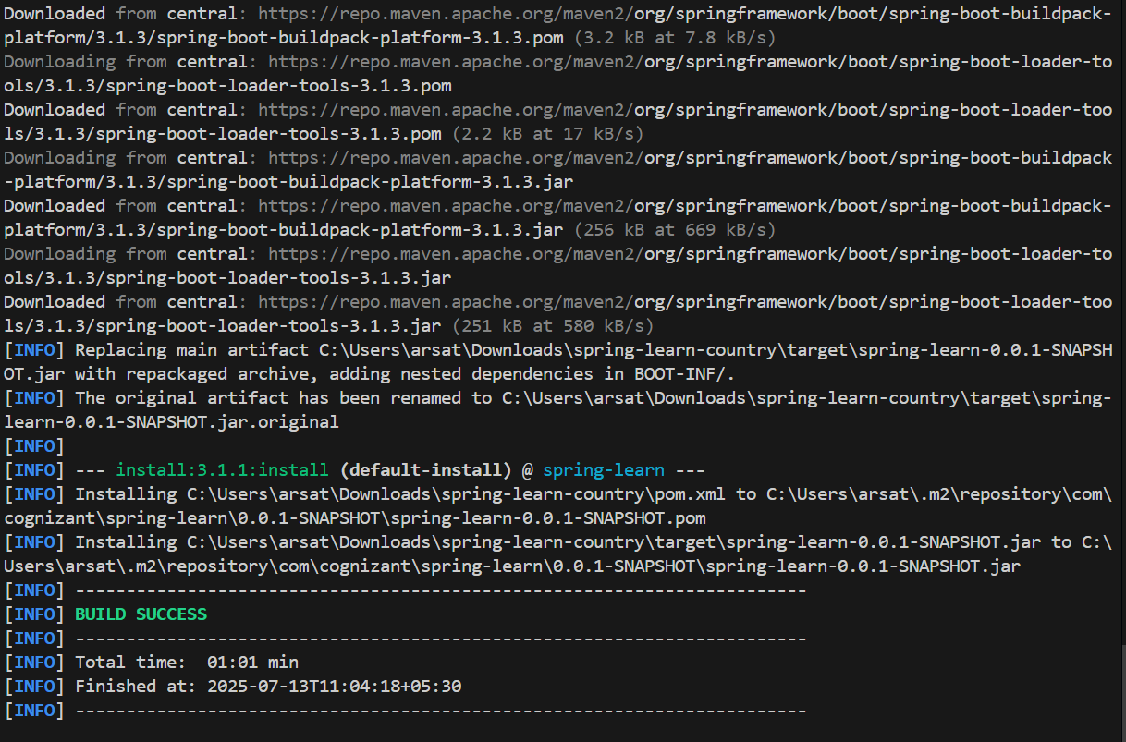**OUTPUT :**

**Spring Core – Load Country from Spring Configuration XML**

**Country.java**

package com.cognizant.springlearn;

import org.slf4j.Logger;

import org.slf4j.LoggerFactory;

public class Country {

    private static final Logger LOGGER = LoggerFactory.getLogger(Country.class);

    private String code;

    private String name;

    public Country() {

        LOGGER.debug("Inside Country Constructor.");

    }

    public String getCode() {

        LOGGER.debug("Getting country code");

        return code;

    }

    public void setCode(String code) {

        LOGGER.debug("Setting country code");

        this.code = code;

    }

    public String getName() {

        LOGGER.debug("Getting country name");

        return name;

    }

    public void setName(String name) {

        LOGGER.debug("Setting country name");

        this.name = name;

    }

    @Override

    public String toString() {

        return "Country [code=" + code + ", name=" + name + "]";

    }

}

**SpringLearnApplication.java**

package com.cognizant.springlearn;

import org.springframework.boot.SpringApplication;

import org.springframework.boot.autoconfigure.SpringBootApplication;

import org.slf4j.Logger;

import org.slf4j.LoggerFactory;

import org.springframework.context.ApplicationContext;

import org.springframework.context.support.ClassPathXmlApplicationContext;

@SpringBootApplication

public class SpringLearnApplication {

    private static final Logger LOGGER = LoggerFactory.getLogger(SpringLearnApplication.class);

    public static void main(String[] args) {

        SpringApplication.run(SpringLearnApplication.class, args);

        LOGGER.info("STARTED SpringLearnApplication main()");

        displayCountry();

    }

    public static void displayCountry() {

        ApplicationContext context = new ClassPathXmlApplicationContext("country.xml");

        Country country = context.getBean("country", Country.class);

        LOGGER.debug("Country : {}", country.toString());

    }

}

**Country.xml**

<?xml version="1.0" encoding="UTF-8"?>

<beans xmlns="http://www.springframework.org/schema/beans"

       xmlns:xsi="http://www.w3.org/2001/XMLSchema-instance"

       xsi:schemaLocation="http://www.springframework.org/schema/beans

       http://www.springframework.org/schema/beans/spring-beans.xsd">

    <bean id="country" class="com.cognizant.springlearn.Country">

        <property name="code" value="IN" />

        <property name="name" value="India" />

    </bean>

</beans>

**Class**

**Country.xml**

<?xml version="1.0" encoding="UTF-8"?>

<beans xmlns="http://www.springframework.org/schema/beans"

       xmlns:xsi="http://www.w3.org/2001/XMLSchema-instance"

       xsi:schemaLocation="http://www.springframework.org/schema/beans

       http://www.springframework.org/schema/beans/spring-beans.xsd">

    <bean id="country" class="com.cognizant.springlearn.Country">

        <property name="code" value="IN" />

        <property name="name" value="India" />

    </bean>

</beans>

**pom.properties**

artifactId=spring-learn

groupId=com.cognizant

version=0.0.1-SNAPSHOT

**pom.xml**

<project xmlns="http://maven.apache.org/POM/4.0.0"

         xmlns:xsi="http://www.w3.org/2001/XMLSchema-instance"

         xsi:schemaLocation="http://maven.apache.org/POM/4.0.0

         http://maven.apache.org/xsd/maven-4.0.0.xsd">

    <modelVersion>4.0.0</modelVersion>

    <groupId>com.cognizant</groupId>

    <artifactId>spring-learn</artifactId>

    <version>0.0.1-SNAPSHOT</version>

    <packaging>jar</packaging>

    <name>spring-learn</name>

    <description>Spring Web Project</description>

    <parent>

        <groupId>org.springframework.boot</groupId>

        <artifactId>spring-boot-starter-parent</artifactId>

        <version>3.1.3</version>

        <relativePath/> <!-- lookup parent from repository -->

    </parent>

    <properties>

        <java.version>17</java.version>

    </properties>

    <dependencies>

        <dependency>

            <groupId>org.springframework.boot</groupId>

            <artifactId>spring-boot-starter-web</artifactId>

        </dependency>

        <dependency>

            <groupId>org.springframework.boot</groupId>

            <artifactId>spring-boot-devtools</artifactId>

            <scope>runtime</scope>

            <optional>true</optional>

        </dependency>

        <dependency>

            <groupId>org.springframework.boot</groupId>

            <artifactId>spring-boot-starter-test</artifactId>

            <scope>test</scope>

        </dependency>

    </dependencies>

    <build>

        <plugins>

            <plugin>

                <groupId>org.springframework.boot</groupId>

                <artifactId>spring-boot-maven-plugin</artifactId>

            </plugin>

        </plugins>

    </build>

</project>

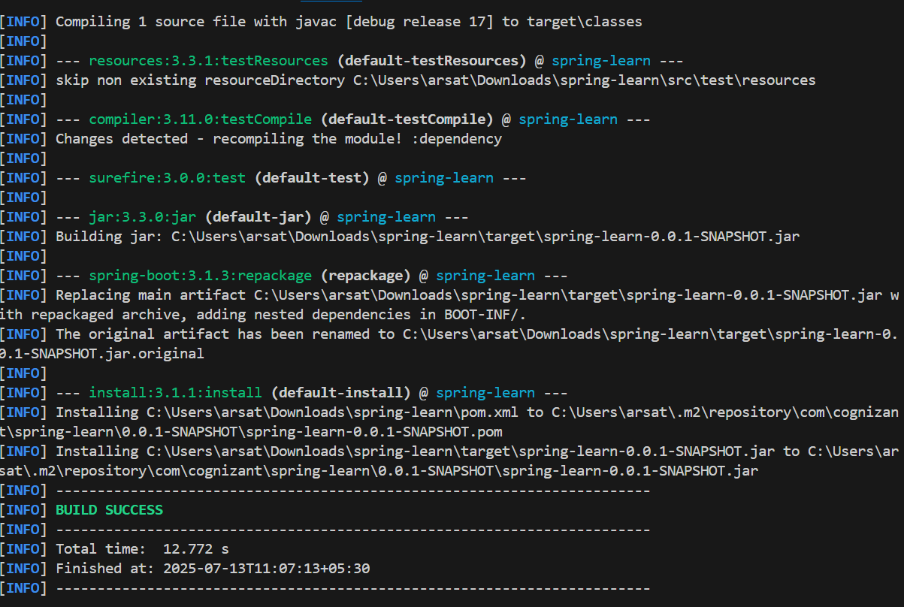**OUTPUT :**